Network Security 1 Project, Rubric 1

Understanding and Implementing a LAN Network Topology

Introduction
A Local Area Network (LAN) connects computers and other devices within a limited geographic area, such as a school, office, or home. A common LAN configuration is a star topology, where every device connects to a central network switch. This design is widely used because it is easy to manage, troubleshoot, and secure.

Network Topology Diagram

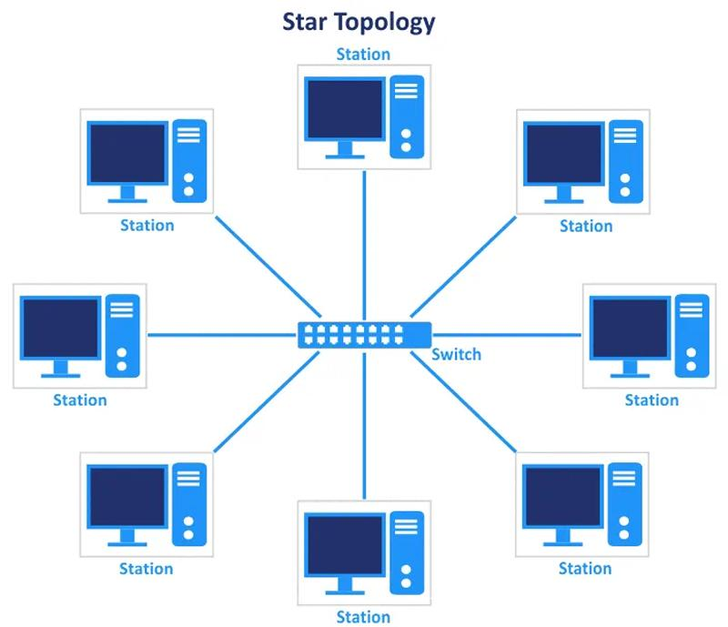

I will add a router to connect to the switch. I will configure it as a fire wall to give more protection to the network.
Adding VLANs would provide more security to the network.

In this configuration, the firewall/router controls traffic between the LAN and the Internet, while the central switch connects wired devices. A wireless access point provides connectivity for mobile and wireless devices.

How the LAN Supports Secure Communication
A LAN can provide several layers of security:
- Firewall protection: The firewall can block unauthorized traffic entering or leaving the network and control which services users can access.
- Network authentication: User accounts, strong passwords, and technologies such as WPA3 for Wi-Fi can prevent unauthorized devices from joining the network.
- Encryption: Encrypted connections such as HTTPS and secure VPN connections protect information while it travels across the network.
- Network segmentation: VLANs can separate groups of devices. For example, employee computers, guest Wi-Fi users, and servers can be placed on separate logical networks.
- Access controls: Administrators can restrict users and devices so they only access the resources they need.
- Monitoring: Logs and network-monitoring tools can identify unusual activity, failed login attempts, or potential security threats.

How the Topology Supports Network Management
The star topology makes network management relatively straightforward because devices connect through a central switch. If one computer or cable fails, the other devices can normally continue operating. Administrators can also manage the network from central equipment rather than configuring every device independently.
A network administrator can:
- Monitor traffic and connected devices from the switch and router.
- Diagnose connectivity problems by checking individual switch ports.
- Add or remove devices without redesigning the entire network.
- Apply VLANs and access-control policies centrally.
- Update firewall, router, and switch configurations.
- Maintain backups of important server and network configurations.
- Use monitoring and logging to detect performance or security problems.

Advantages and Limitations
Advantages
- Easy to install and expand.
- A failure of one endpoint usually does not affect the rest of the LAN.
- Centralized management improves troubleshooting.
- Security policies can be applied at key network points.
- Suitable for offices, schools, and other organizations.
Limitations
- The central switch is a critical component; if it fails, connected devices may lose network access.
- More cabling is required than with some other topologies.
- The network requires appropriate security configuration to prevent unauthorized access.

Conclusion
A star-based LAN topology provides an effective balance of performance, security, and manageability. By connecting devices through a central switch and protecting the LAN with a firewall, authentication, encryption, segmentation, and monitoring, organizations can establish secure communication while making the network easier to administer and troubleshoot. Although the central switch represents a potential point of failure, redundant switches and other backup measures can improve reliability.

